Group Member: Yinan Fu; Bolin Dai; Chengzhang Li; Jing Li

Seed Ideas:

#1. We want to make the appearance of our flashlight as a revolver with the color LED inside the gun-barrel and 4 single-color LEDs located on wheel of the revolver just like the image below:

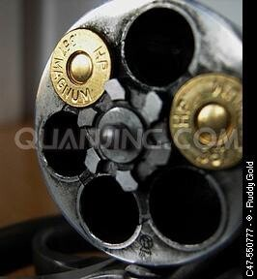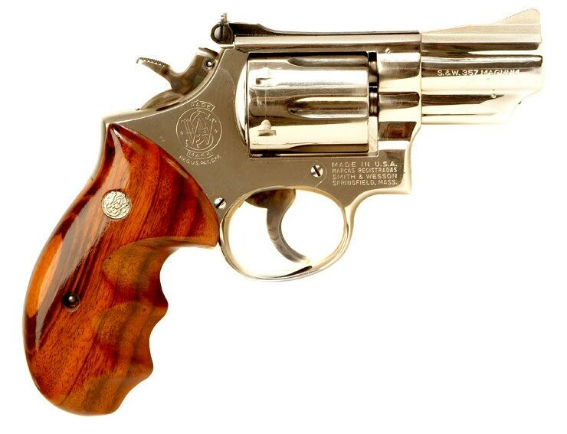

Single-color

LED

Color LED

#2. We design 2 special lighting models. One is SOS model: All the flashlights will flicker 6 times as a period. In the first 3 times the lights will be lighted for 0.5s and go dark each time. In the other 3 times the lights will keep on for 0.2s then go dark each time. And this lighting model will repeat again and again.

#3.Shooting Model: When you press the trigger the LED light will light once, but not the same every time you press. Normally, the light will flash once with white color. In other case the light will be bloody-red color lasting 1s just like someone being shot. Both cases will happen randomly.